Legacy Books
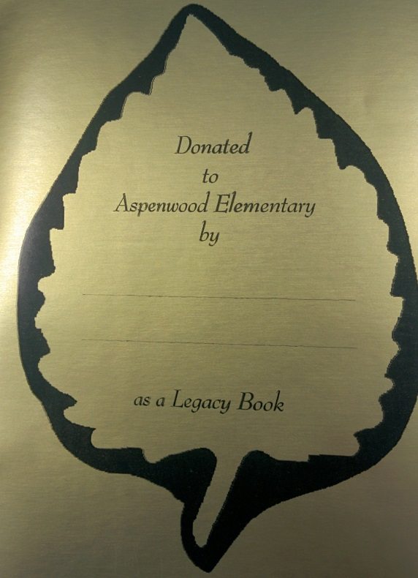
Do you want to help your school library and also have your child leave a little legacy even after they have moved on? How, do you ask? You can buy one!
Mrs. Coutts has purchased a variety of books for the school library. You can then purchase these books for $5, $10, or $15 (depending on the book). When you buy this legacy book you are buying it for the library but your child will get a special legacy book sticker put into this book which will live on for the life of the book. Your child can take this book home immediately and when they are finished reading it they will bring it back to the library and put into circulation for all students.
Legacy Book Event
Where? Aspenwood Elementary
Front Foyer near Music room
When? Sept. 21st and 22nd 2 pm- 4 pm
How do I pay?: Cash or cheque

